CSA1717-ARTIFICIAL INTELLIGENCE
PRACTICAL LAB EXPERIMENTS
RAGAVI S – (192565027)

EXPERIMENT 1: 8-PUZZLE PROBLEM
Aim
The aim of this experiment is to solve the 8-Puzzle Problem using the A* Search algorithm by moving tiles on a 3 × 3 grid from a given starting configuration to a target goal state.
Objective
To implement the A* search algorithm and the Manhattan Distance heuristic function to model a 3 × 3 grid and find the shortest path to solve the puzzle.
Algorithm
Step 1: Define the target goal state of the puzzle grid as (1, 2, 3, 4, 5, 6, 7, 8, 0).
Step 2: Accept the initial starting configuration of the puzzle from the user.
Step 3: Compute the initial Manhattan Distance ($h$) by calculating how many steps each misplaced number sits away from its correct goal position.
Step 4: Place the starting configuration into a priority queue, sorted by the total cost ($f=g+h$), where $g$ is the number of moves made so far.
Step 5: Retrieve the node with the lowest total cost ($f$) from the priority queue.
Step 6: Check if this configuration matches the goal state. If yes, print the step-by-step path to the solution and stop.
Step 7: If it is not the goal, locate the empty tile (0) and swap it with its adjacent numbers (Up, Down, Left, or Right) to generate new child board states.
Step 8: For each new child state, check if it has been visited before. If it is unvisited, calculate its cost ($f$), add it to the queue, and return to Step 5.
Source Code
import heapq
GOAL = (1, 2, 3, 4, 5, 6, 7, 8, 0)
def h(state):
return sum(abs(i//3 - GOAL.index(x)//3) + abs(i%3 - GOAL.index(x)%3)
for i, x in enumerate(state) if x)
def get_neighbors(state):
neighbors = []
blank = state.index(0)
r, c = divmod(blank, 3)
for dr, dc in [(-1,0), (1,0), (0,-1), (0,1)]:
if 0 <= r+dr < 3 and 0 <= c+dc < 3:
target = (r+dr)*3 + (c+dc)
new_state = list(state)
new_state[blank], new_state[target] = new_state[target], new_state[blank]
neighbors.append(tuple(new_state))
return neighbors
def solve(start):
queue = [(h(start), 0, start, [])]
visited = {start}
while queue:
_, g, curr, path = heapq.heappop(queue)
if curr == GOAL: return path + [curr]
for nxt in get_neighbors(curr):
if nxt not in visited:
visited.add(nxt)
heapq.heappush(queue, (g + 1 + h(nxt), g + 1, nxt, path + [curr]))
return None
# --- Custom Input Handling ---
if __name__ == "__main__":
user_in = input("Enter 9 numbers (0-8) separated by spaces: ")
start_state = tuple(map(int, user_in.split()))

if len(start_state) != 9 or set(start_state) != set(range(9)):
print("Error: Please enter exactly 9 unique digits from 0 to 8.")
else:
solution = solve(start_state)
if solution:
print(f"\nSolved in {len(solution)-1} steps:")
for step, state in enumerate(solution):
print(f"Step {step}:")
for i in range(0, 9, 3): print(list(state[i:i+3]))
print()
else:
print("This specific puzzle layout is mathematically unsolvable!")

Flowchart
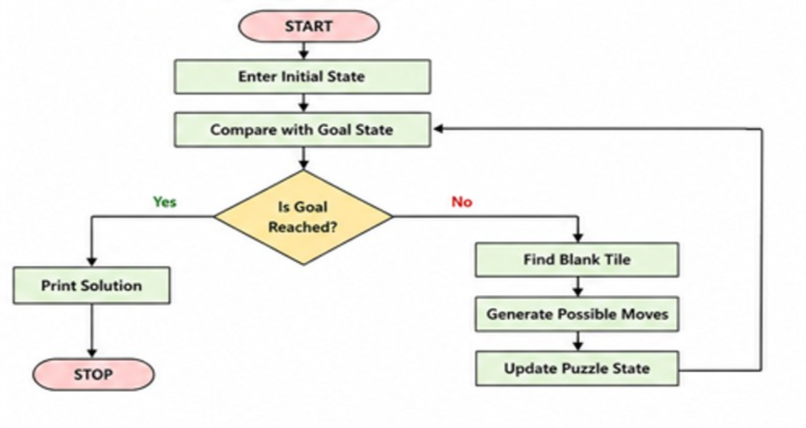

Output
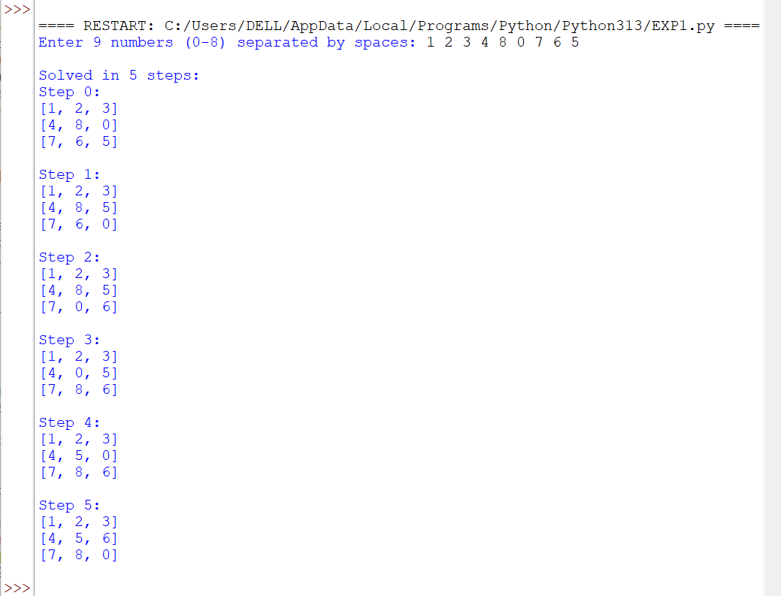
Result
The 8-Puzzle problem was successfully solved using the A* Search algorithm by finding the fastest sequence of tile moves from the initial state to the target goal state.

